UNITED STATES
SECURITIES AND EXCHANGE COMMISSION
Washington, D.C. 20549

SCHEDULE 14A
Proxy Statement Pursuant to Section 14(a) of the
Securities Exchange Act of 1934

Filed by the Registrant ☒
Filed by a party other than the Registrant ☐
Check the appropriate box:

☐ | Preliminary Proxy Statement

☐ | Confidential, for Use of the Commission Only (as permitted by Rule 14a-6(e)(2))

☐ | Definitive Proxy Statement

☒ | Definitive Additional Materials

☐ | Soliciting Material under §240.14a-12
CBIZ, INC.
(Name of Registrant as Specified in its Charter)
Not applicable
(Name of Person(s) Filing Proxy Statement, if other than the Registrant)
Payment of Filing Fee (Check all boxes that apply):

☒ | No fee required

☐ | Fee paid previously with preliminary materials

☐ | Fee computed on table in exhibit required by Item 25(b) per Exchange Act Rules 14a-6(i)(1) and 0-11

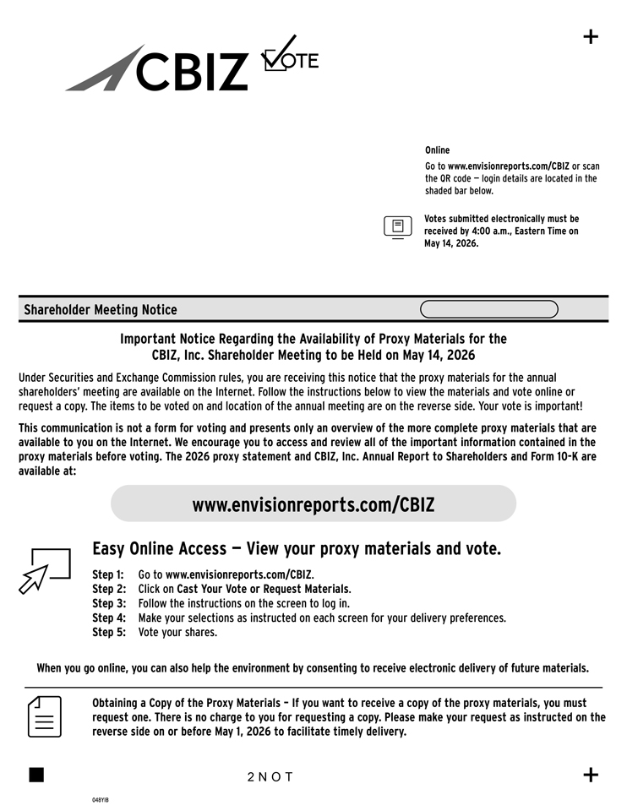
Online Go to www.envisionreports.com/CBIZ or scan the QR code — login details are located in the shaded bar below. Votes submitted electronically must be received by 4:00 a.m., Eastern Time on May 14, 2026. Shareholder Meeting Notice Important Notice Regarding the Availability of Proxy Materials for the CBIZ, Inc. Shareholder Meeting to be Held on May 14, 2026 Under Securities and Exchange Commission rules, you are receiving this notice that the proxy materials for the annual shareholders’ meeting are available on the Internet. Follow the instructions below to view the materials and vote online or request a copy. The items to be voted on and location of the annual meeting are on the reverse side. Your vote is important! This communication is not a form for voting and presents only an overview of the more complete proxy materials that are available to you on the Internet. We encourage you to access and review all of the important information contained in the proxy materials before voting. The 2026 proxy statement and CBIZ, Inc. Annual Report to Shareholders and Form 10-K are available at: www.envisionreports.com/CBIZ Easy Online Access — View your proxy materials and vote. Step 1: Go to www.envisionreports.com/CBIZ. Step 2: Click on Cast Your Vote or Request Materials. Step 3: Follow the instructions on the screen to log in. Step 4: Make your selections as instructed on each screen for your delivery preferences. Step 5: Vote your shares. When you go online, you can also help the environment by consenting to receive electronic delivery of future materials. Obtaining a Copy of the Proxy Materials – If you want to receive a copy of the proxy materials, you must request one. There is no charge to you for requesting a copy. Please make your request as instructed on the reverse side on or before May 1, 2026 to facilitate timely delivery. 2 N O T

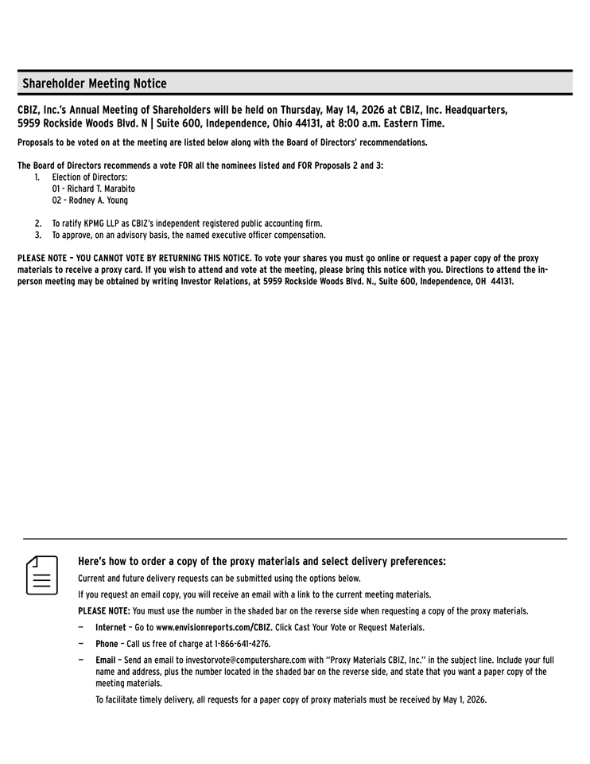
Shareholder Meeting Notice CBIZ, Inc.’s Annual Meeting of Shareholders will be held on Thursday, May 14, 2026 at CBIZ, Inc. Headquarters, 5959 Rockside Woods Blvd. N | Suite 600, Independence, Ohio 44131, at 8:00 a.m. Eastern Time. Proposals to be voted on at the meeting are listed below along with the Board of Directors’ recommendations. The Board of Directors recommends a vote FOR all the nominees listed and FOR Proposals 2 and 3: 1. Election of Directors: 01—Richard T. Marabito 02—Rodney A. Young 2. To ratify KPMG LLP as CBIZ’s independent registered public accounting firm. 3. To approve, on an advisory basis, the named executive officer compensation. PLEASE NOTE – YOU CANNOT VOTE BY RETURNING THIS NOTICE. To vote your shares you must go online or request a paper copy of the proxy materials to receive a proxy card. If you wish to attend and vote at the meeting, please bring this notice with you. Directions to attend the in-person meeting may be obtained by writing Investor Relations, at 5959 Rockside Woods Blvd. N., Suite 600, Independence, OH 44131. Here’s how to order a copy of the proxy materials and select delivery preferences: Current and future delivery requests can be submitted using the options below. If you request an email copy, you will receive an email with a link to the current meeting materials. PLEASE NOTE: You must use the number in the shaded bar on the reverse side when requesting a copy of the proxy materials. — Internet – Go to www.envisionreports.com/CBIZ. Click Cast Your Vote or Request Materials. — Phone – Call us free of charge at 1-866-641-4276. — Email – Send an email to investorvote@computershare.com with “Proxy Materials CBIZ, Inc.” in the subject line. Include your full name and address, plus the number located in the shaded bar on the reverse side, and state that you want a paper copy of the meeting materials. To facilitate timely delivery, all requests for a paper copy of proxy materials must be received by May 1, 2026.

